
COMPUTER ENGINEERING
OOPM ODD SEM 2021-22/EXPERIMENT 3 NAME:- GAURAV AMARNANI (D7A, 67)

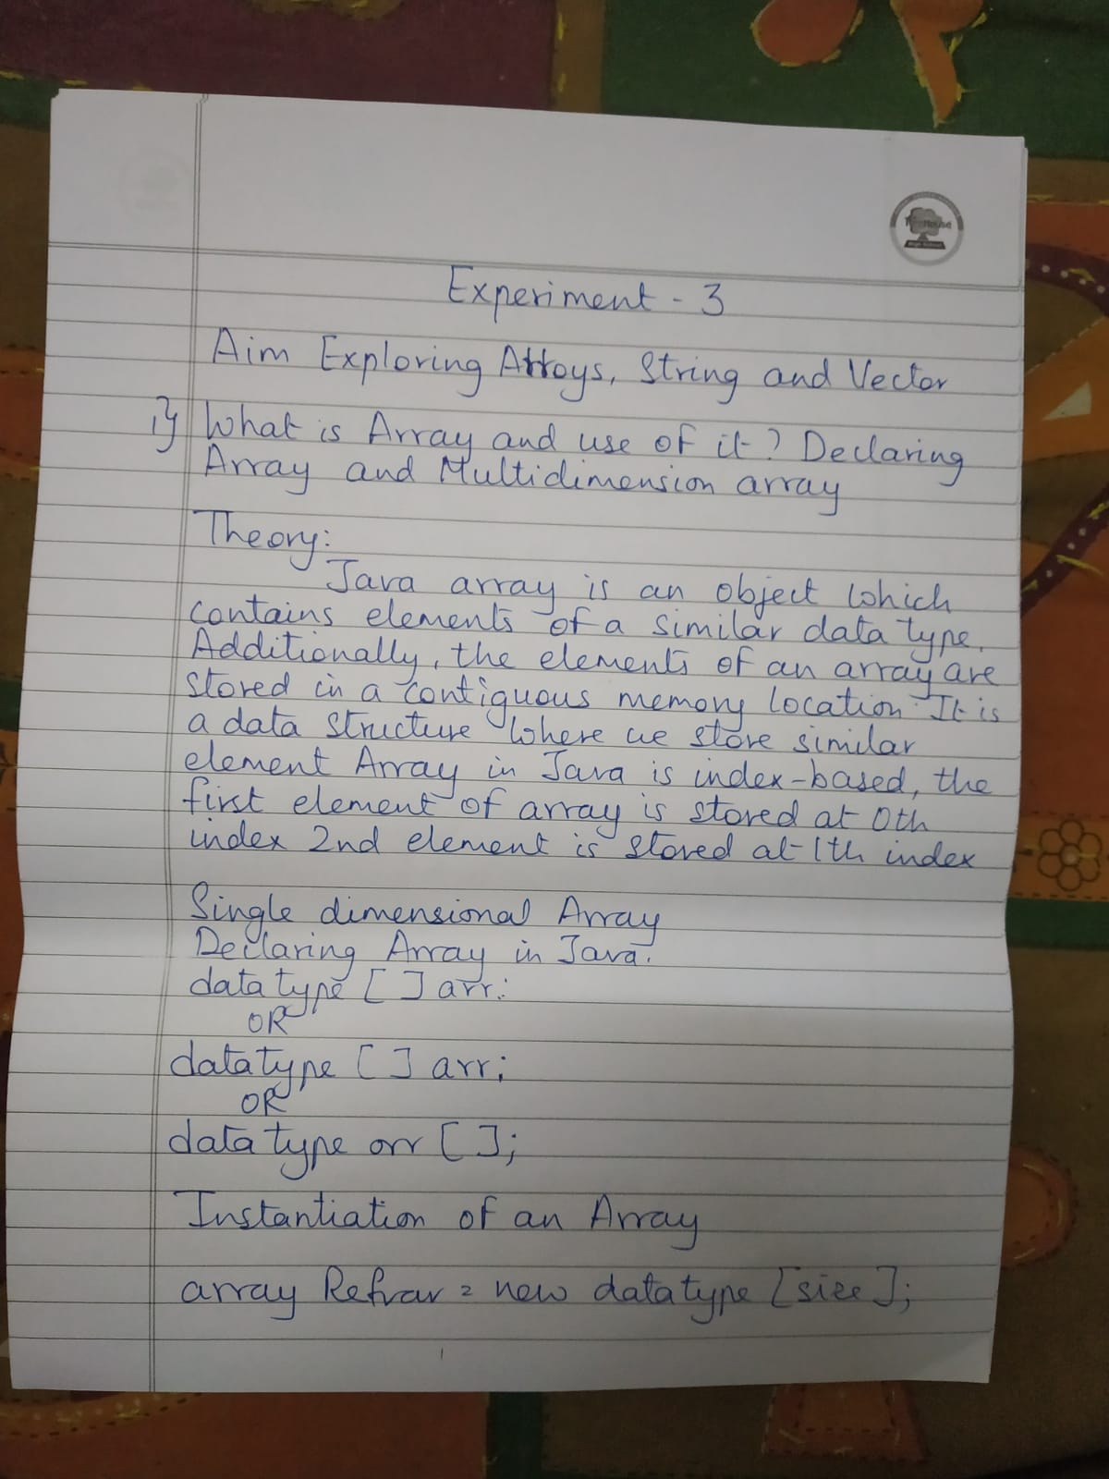
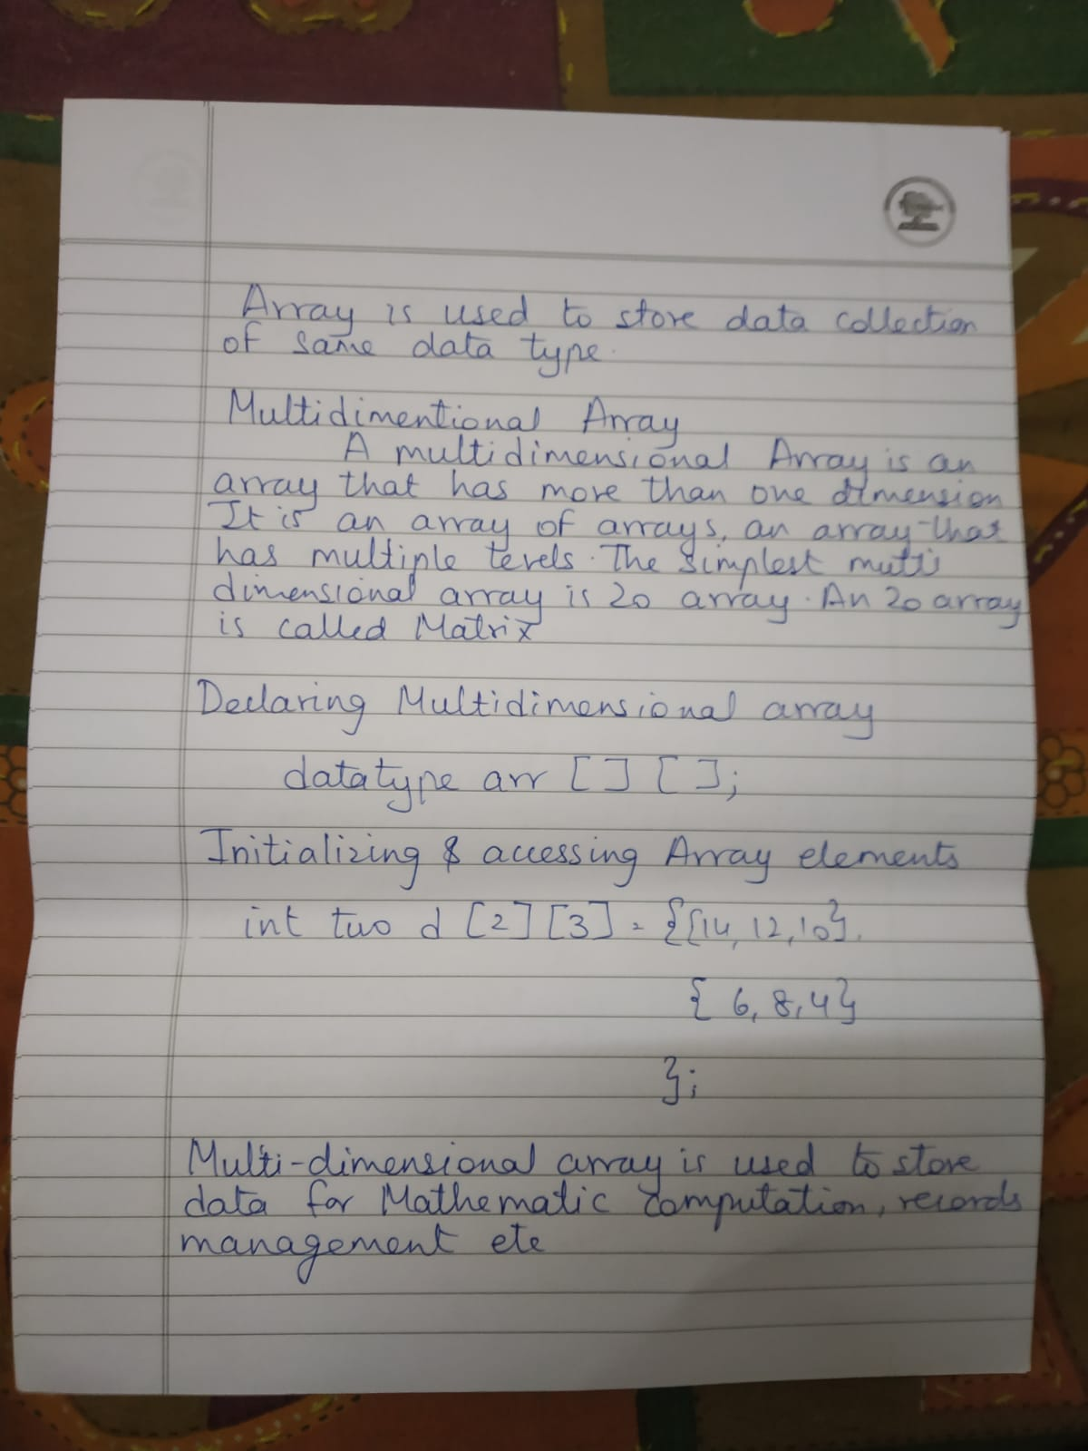
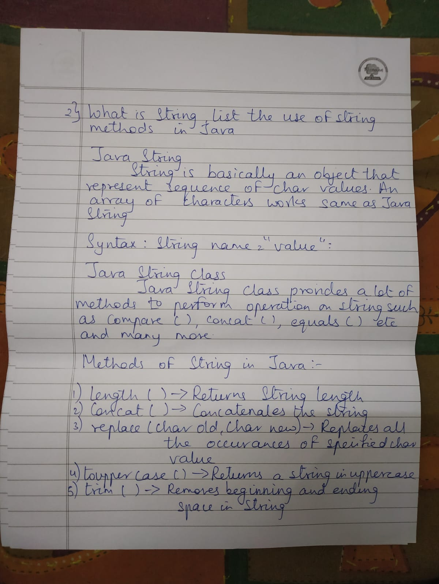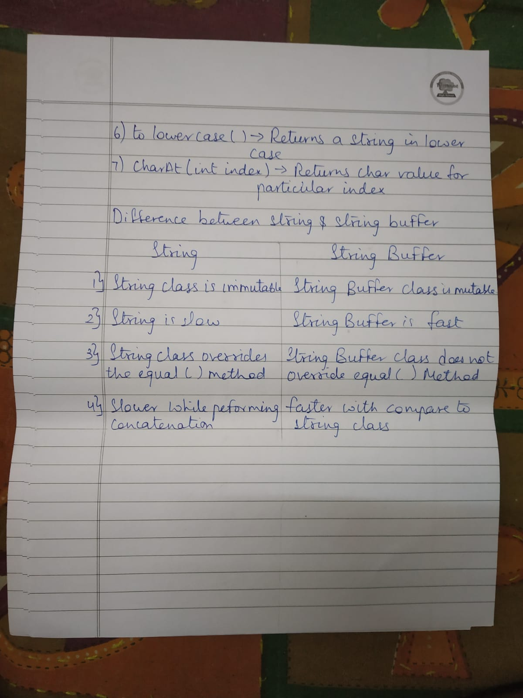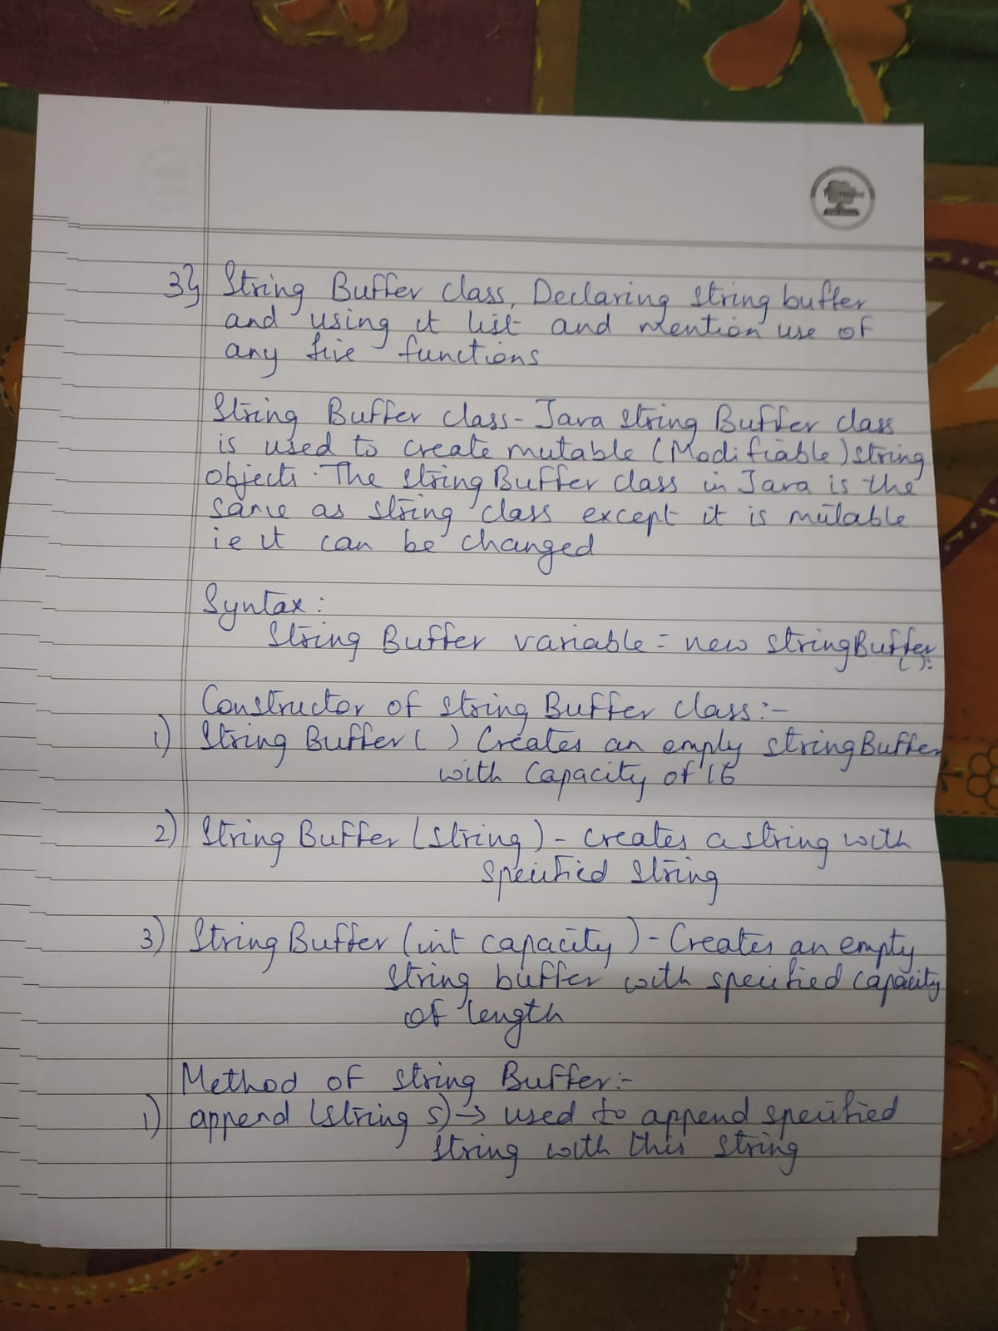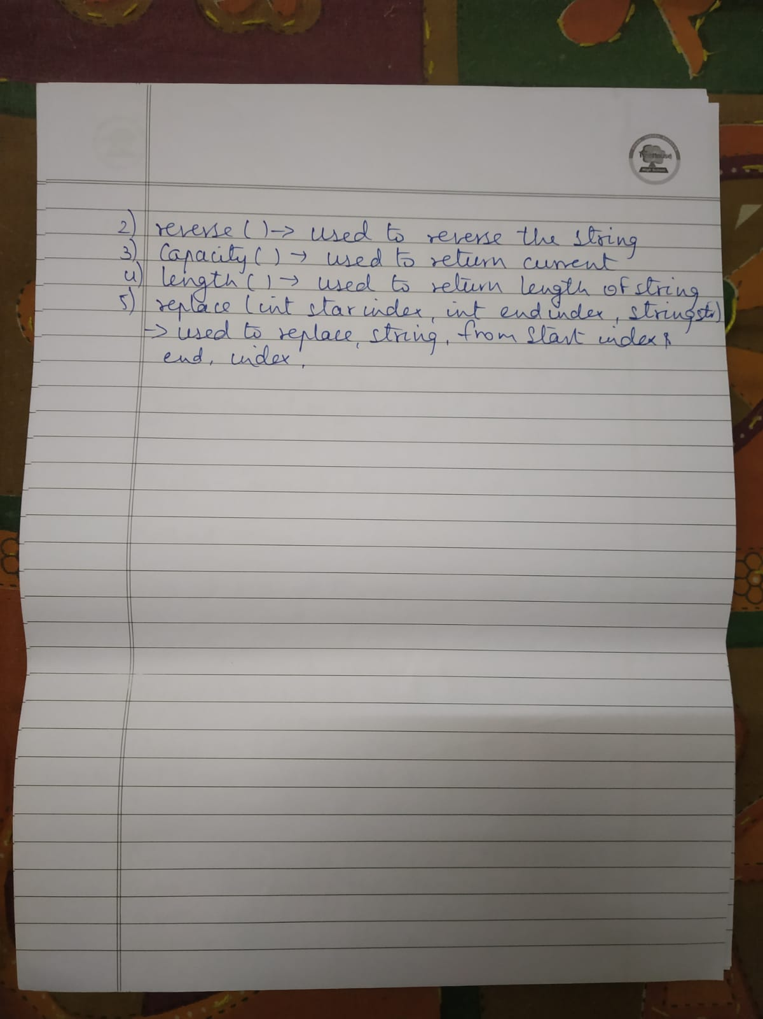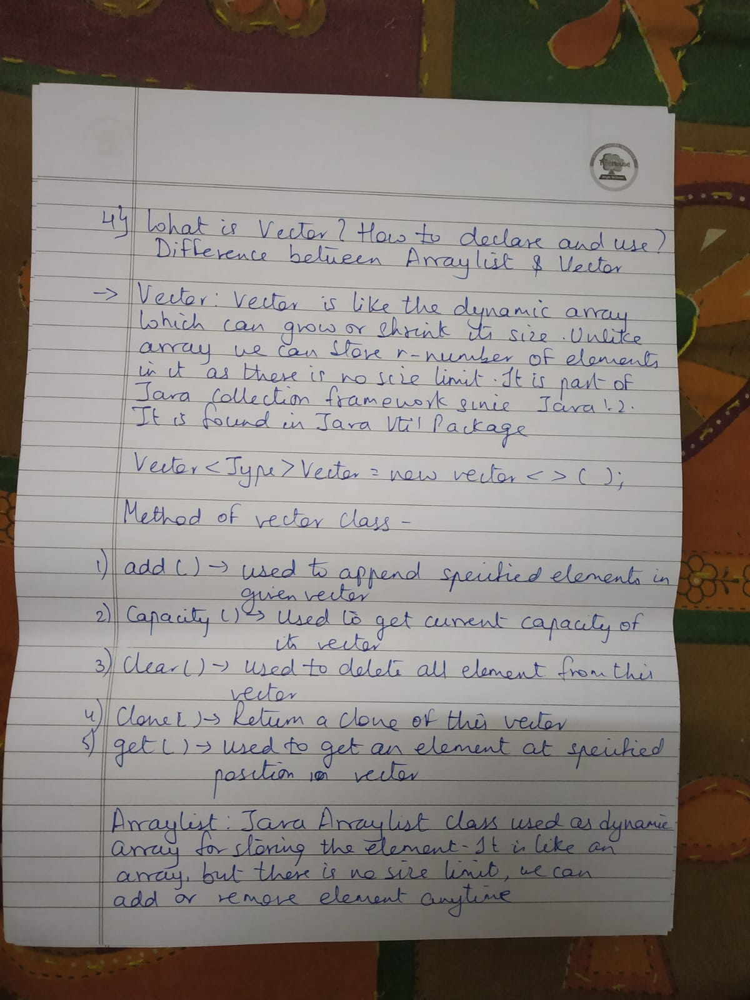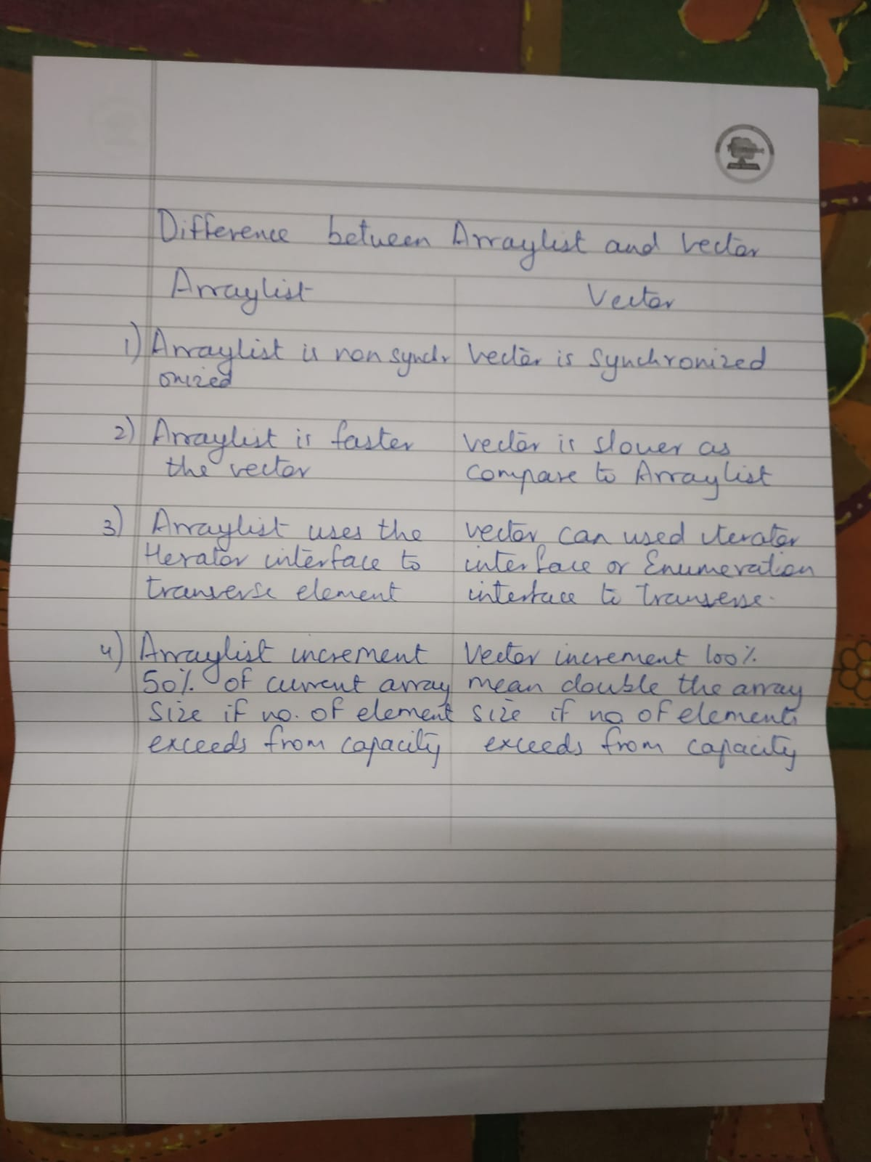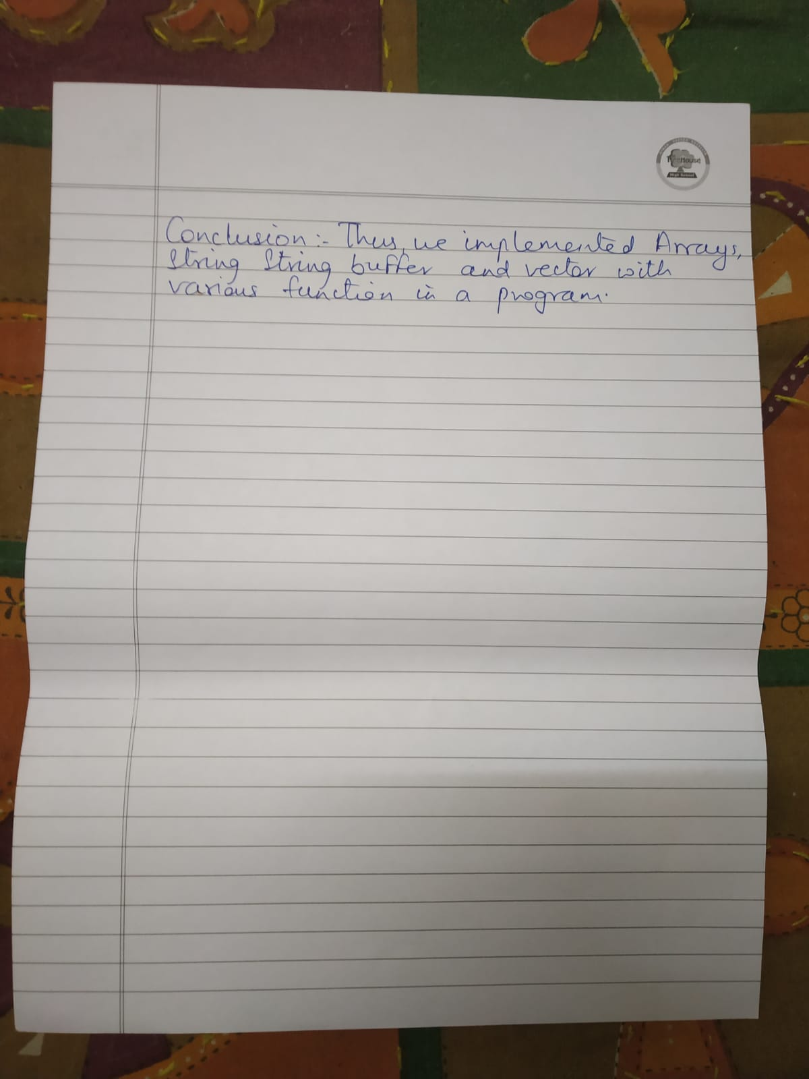

Program:

Program 1

Aim: To perform Matrix Multiplication Code-

import java.util.*;

class MatrixMultiplication {
public static void main( String args [ ] ) {
Scanner sc=new Scanner(System.in); int i,j,k,r,c,r1,c1,r2,c2;
System.out.println("Enter the number of rows and columns of matrix 1:"); r1=sc.nextInt();
c1=sc.nextInt();
System.out.println("Enter the number of rows and columns of matrix 2:"); r2=sc.nextInt();
c2=sc.nextInt();
if(c1==r2) {
r=r1; c=c2;
int [ ] [ ] a=new int [r1][c1];
int [ ] [ ] b=new int [r2][c2];
int [ ] [ ] product=new int [r][c];
System.out.println("Enter elements of Matrix 1:");
for(i=0;i<r1;i++) {
for(j=0;j<c1;j++) {
a[i][j]=sc.nextInt();
}
}
System.out.println("Enter elements of Matrix 2:");
for(i=0;i<r2;i++) {
for(j=0;j<c2;j++) {
b[i][j]=sc.nextInt();
}
}
for(i=0;i<r;i++) {
for(j=0;j<c;j++) {
for(k=0;k<c1;k++)
product[i][j]+=a[i][k]*b[k][j];
}
}
System.out.println("Product after Matrix Multiplication is");
for(i=0;i<r;i++) {
for(j=0;j<c;j++) {
System.out.print(product[i][j]+" ");
}
System.out.println();
}
}
else
System.out.println("Order Mismatch! Matrix Multiplication not possible!!");
}
}

Output:

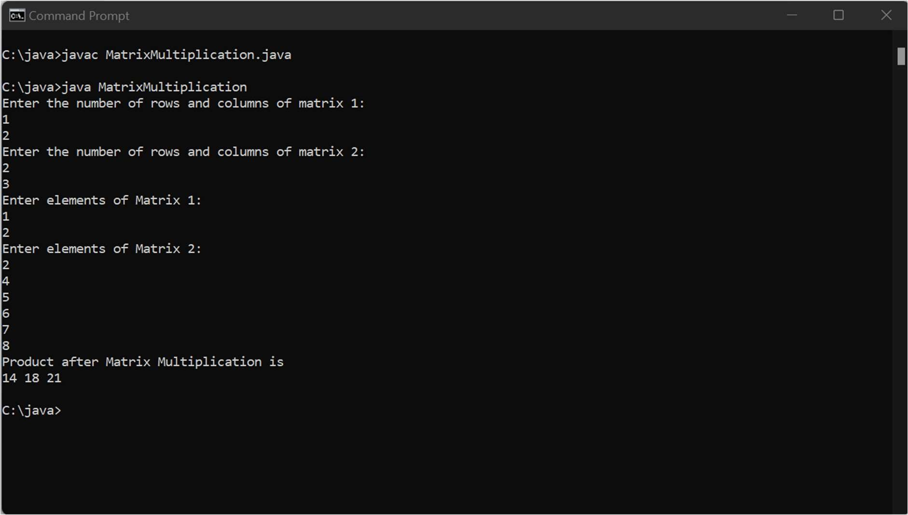

Conclusion-

An array is initialized with all elements as zero as seen here.
Program:

Program 2

Aim: To use functions of string
Code-

import java.lang.*;
import java.util.*;
class Function {
public static void main(String[] args) {
String s5;
Scanner in=new Scanner(System.in);
System.out.println("The string s1 is:");
String s1=in.next();
System.out.println("The length of string is:");
System.out.println(s1.length());
System.out.println("Checking whether the character starts with z");
System.out.println(s1.startsWith("z"));
System.out.println("Checking whether the character ends with o");
System.out.println(s1.endsWith("o"));
System.out.println("Using substring(int beginIndex) we get:");
System.out.println(s1.substring(3));
System.out.println("Using substring(int beginIndex,int endIndex) we get:");
System.out.println(s1.substring(3,6));
System.out.println("Using charAt(int index):");
System.out.println(s1.charAt(2));
System.out.println("The string s2 is:");//hello
String s2=in.next();
System.out.println("Using toUpperCase() we get:");
System.out.println(s2.toUpperCase());
System.out.println("The string s3 is:");
String s3=in.next();
System.out.println("Using toLowerCase() we get");
System.out.println(s3.toLowerCase());
System.out.println("The string s4 is:");
String s4=in.next();
System.out.println("Using trim()");
System.out.println(s4.trim());
System.out.println("Using compareTo() we get:");
System.out.println(s1.compareTo(s2));
System.out.println("Using equals() we get:");
System.out.println(s1.equals(s2));
System.out.println("Using equalsIgnoreCase() we get:");
System.out.println(s2.equalsIgnoreCase(s3));
System.out.println("Using compareToIgnoreCase() we get:");
System.out.println(s2.compareToIgnoreCase(s3));
s5=s1.concat(s2);
System.out.println("Using concat() we get:");
System.out.println(s5);
}
}

Output:

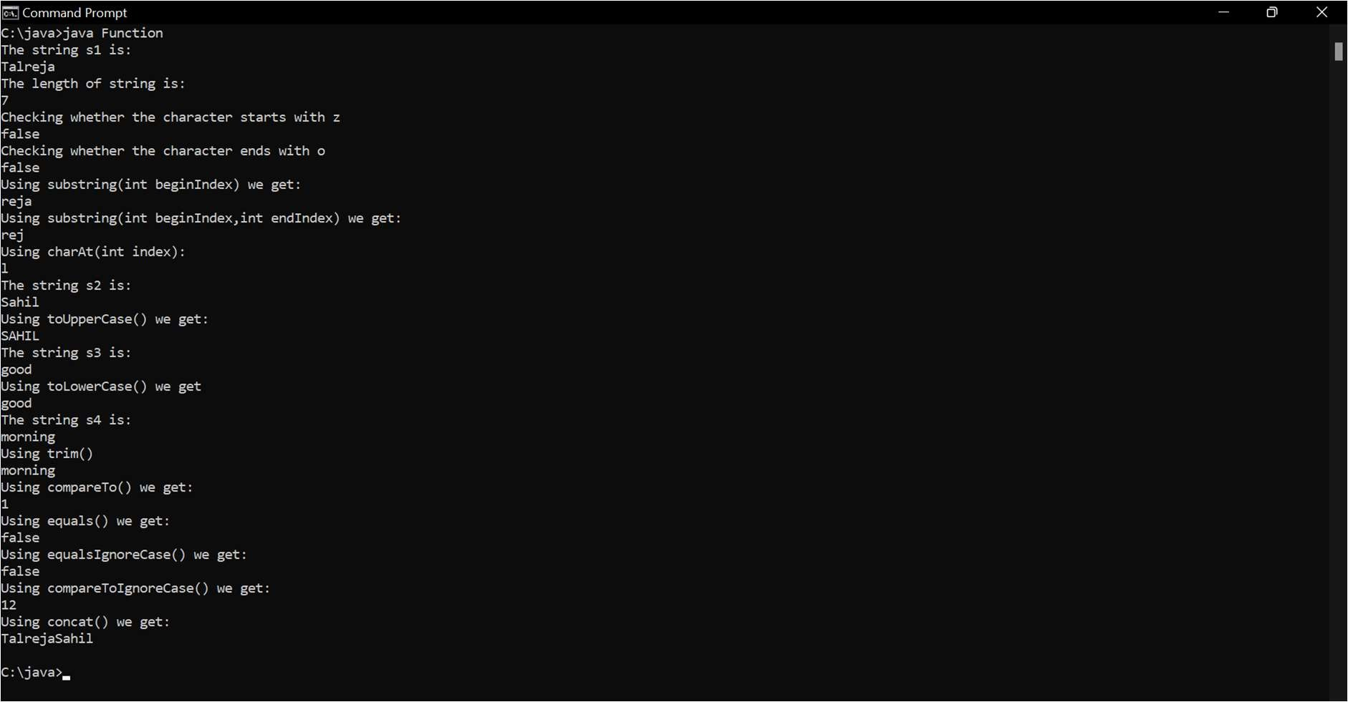

Conclusion-

Different functions of String ,their functionalities and their syntax is learned.
Program:

Program 3

Aim- To use functions of StringBuffer Class

Code-

import java.lang.*;
import java.util.*;
class StringBufferExample {
public static void main(String args[]) {
StringBuffer sb=new StringBuffer("Hello ");
System.out.println("Original element = "+sb);
sb.append("Java");
System.out.println("After Append = "+sb);

StringBuffer sb1=new StringBuffer("Insert ");
System.out.println("Original element = "+sb1);
sb1.insert(2,"now");
System.out.println("After Insert = "+sb1);

StringBuffer sb2=new StringBuffer("Hello");
System.out.println("Original element = "+sb2);
sb2.replace(1,3,"Java");
System.out.println("After Replace = "+sb2);

StringBuffer sb3=new StringBuffer("Computer");
System.out.println("Original element = "+sb3);
sb3.reverse();
System.out.println("After Reverse = "+sb3);

StringBuffer sb4=new StringBuffer("Java");
System.out.println("Original element = "+sb4);
sb.delete(1,3);
System.out.println("After Delete = "+sb4);
StringBuffer sb5=new StringBuffer();
System.out.println("Capacity = "+sb5.capacity());

StringBuffer sb6=new StringBuffer("Laptop");
System.out.println("After substring(beginindex,endIndex) = "+sb6.substring(2,4));
System.out.println("After substring(beginindex) = "+sb6.substring(2));
}
}

Output:
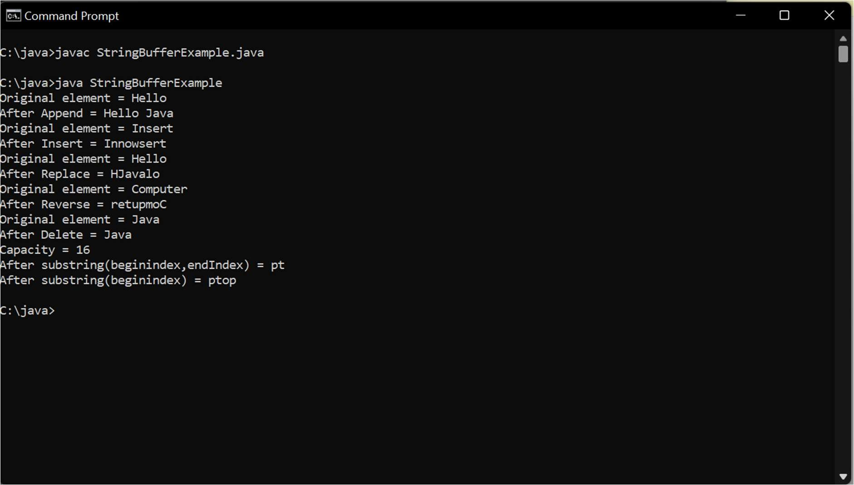

Conclusion-

Learned to use various functions of String Buffer class.
Program:

Program 4

Aim- To use functions of StringBuffer Class

Code-
import java.lang.*;
import java.util.*;
public class VectorExample {
public static void main(String args[]) {
Vector<Integer> in = new Vector<>(); in.add(100);
in.add(200);
in.add(300);
in.add(200);
in.add(400);
in.add(500);
in.add(600);
in.add(700);
System.out.println("Values in vector: " +in);
System.out.println("Remove first occourence of element 200: "+in.remove((Integer)200)); System.out.println("Values in vector after remove: " +in);
System.out.println("Remove element at index 4: " +in.remove(4)); System.out.println("New Value list in vector: " +in); in.removeElementAt(5);
System.out.println("Vector element after removal: " +in); System.out.println("Hash code of this vector = "+in.hashCode()); System.out.println("Element at index 1 is = "+in.get(1));
System.out.println("\n");
}
}

Output:

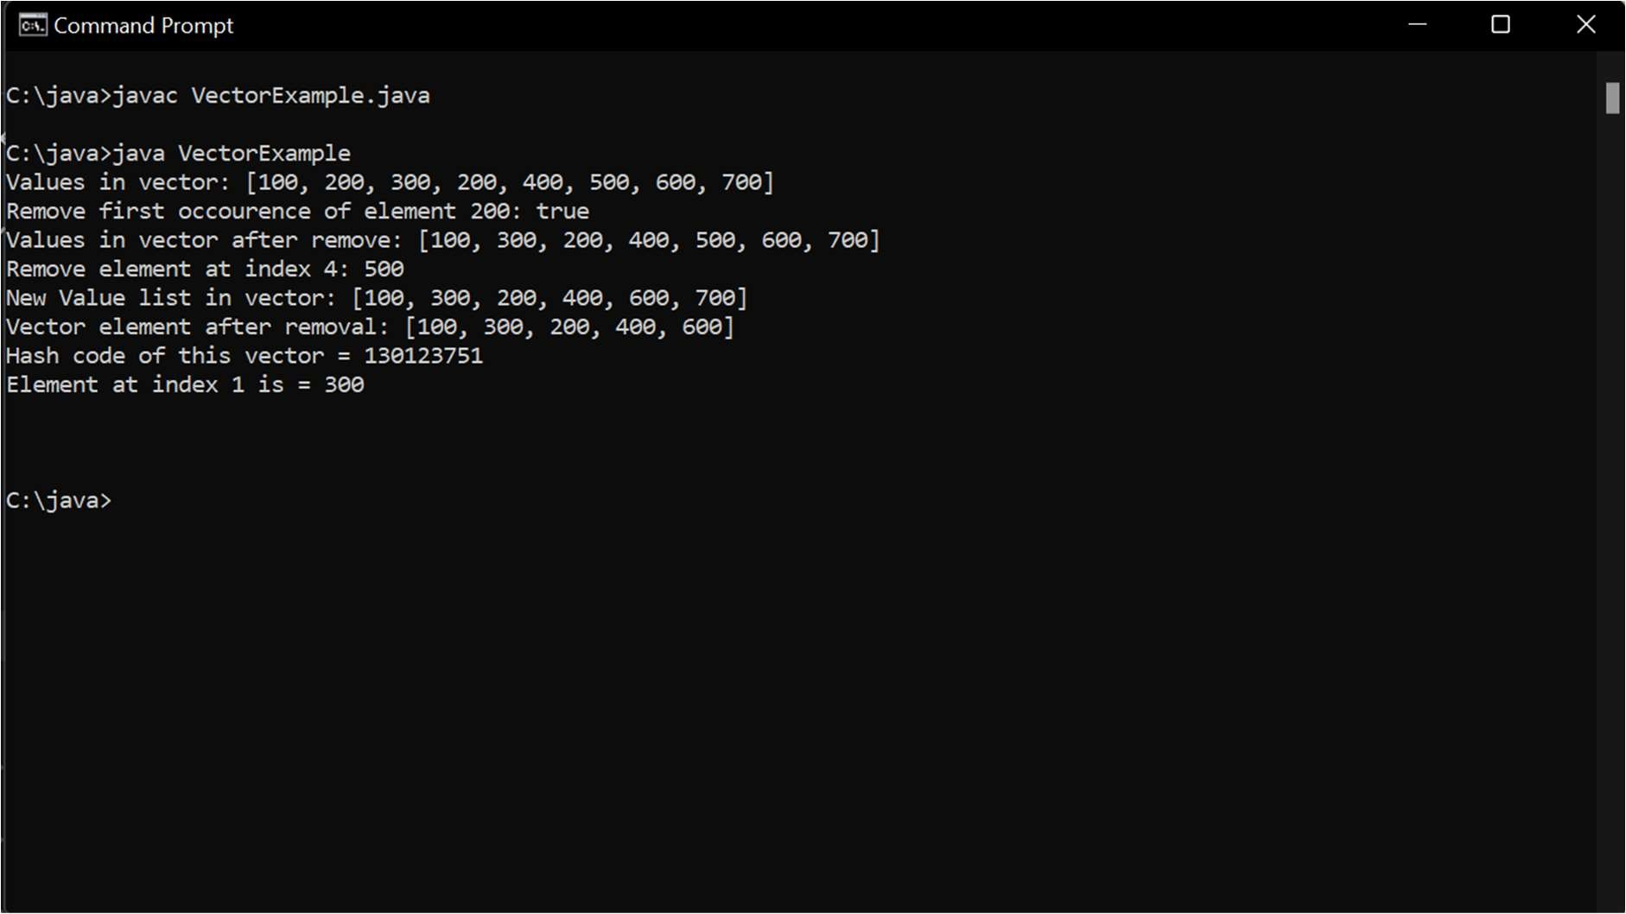

Conclusion-

Learned to use various functions of Vector class.

